Class attribute, ID attribute

ID: only allowed to use unique name once in the entire HTML page, is much more specific – only one element with particular ID name

a space means 2 separate classes, even if in same “”

Note bottom half is CSS class selector.

**Relative path / url**:

Starts with /, means starting from root. /images/logo.gif , means starts from root, go to images folder, then logo.gif

/ = relative to the root level

../ = go up one level.

**index.html**

These 3 urls go to exactly the same place

**Navigation bar**:

**Image**:

alt: acts as a substitute whenever the image can’t be seen, people who are blind e.g., may use a screen reader to read the alt text aloud to them.

alt can be left blank, i.e. alt=””

width, height are not necessary, but will give your browser better performance



srcset: provide different set of images to display with various **resolutions** depending on client hardware / screen, connection speed etc.

sizes: responsive width depending on how big client makes the window

**<head>** html head

part of HTML document that’s never displayed to the user, where the meta / metadata of HTML lives

<link rel=”” href=””>

**<body>** html body

Contents inside <body>: main, header, footer, article, section, aside

<main>: used once per webpage, wraps around the main content of the page

<header> <footer>: logo, sitename, navigation etc.

<article>: wrapped around any instance of an = a unit of content

<section> / <zone>: a flexible element

<aside>: off to the side, e.g. sidebar, inset panel, advertisment

**<form>**, connecting label to input element

Type checking:

e.g. in attribute, type=”email”, typ=”submit”, required, placeholder(default value, disappears once enter something), value=”” (repopulate input with real value) <= forms that autocomplete

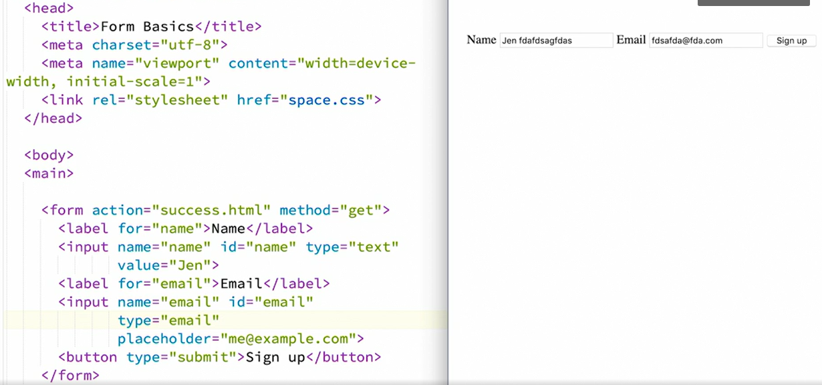

**table**:

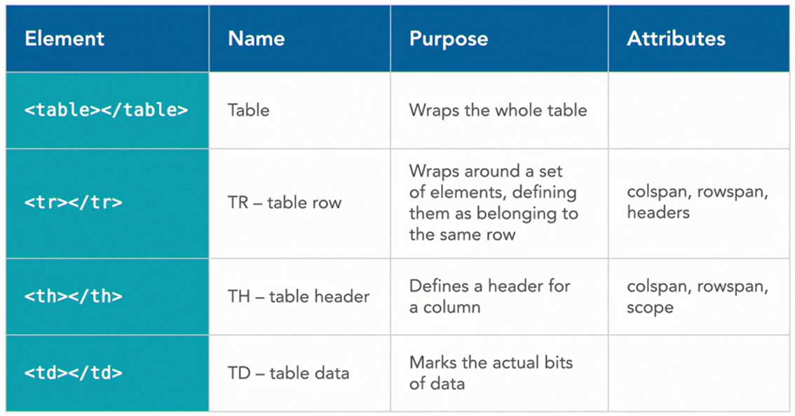

In-Page linking / In Page linking

